Usability Evaluation Report
COS20001 - User-Centred Design
Due date: 30/03/2025
Team Code (from Canvas): Group 2
Names of contributing students:
- Ta Quang Tung - 104222196
- Nguyen Quang Huy - 104169507
- Do Quang Minh - 104175326
- Doan Trung Nghia - 104221559
- Pham Quang Minh - 104999568
Word count: 4338 words

Contribution Statements
Name | Contribution
Ta Quang Tung | Section 3 - Usability Evaluation Method  Section 4 - Results  Proof-reading and formatting document
Nguyen Quang Huy | Section 4 - Results  Section 5 - Usability Problem Identification  Formatting document
Do Quang Minh | Section 6 - Limitations  Section 7 - Appendices
Doan Trung Nghia | Section 2 - Usability Requirements
Pham Quang Minh | Executive Summary  Section 1 - Background
Table 1: Team contribution

Executive Summary
This document presents the usability evaluation of Freedom Tracker, an application designed to assist caregivers while allowing individuals with dementia to maintain independence. The evaluation involved four participants who provided consent to test the prototype and offer feedback. We begin by detailing the usability evaluation method, including the participant selection process, evaluation materials, and procedures. The study was designed to assess ease of use, effectiveness, and any challenges users faced while interacting with the application. Participants engaged in key tasks reflecting real-world usage scenarios, and their interactions were observed and recorded for analysis. The results highlight both strengths and areas for improvement. Positive feedback focused on the app’s user-friendly interface and essential features that enhance safety and monitoring. However, several usability issues were identified, including navigation difficulties and the need for clearer instructions. These findings led to key usability problems being documented, along with recommendations for improvement. Despite these constraints, the evaluation still provides valuable insights into the user experience, guiding future refinements of Freedom Tracker to better meet the needs of caregivers for individuals with dementia.

Table of Contents
Usability Evaluation Report 1
Contribution Statements 2
Executive Summary 3
Table of Contents 4
1 Background 5
2 Usability Requirements 7
3 Usability Evaluation Method 10
3.1 Participants 10
3.2 Materials 11
3.3 Tasks 12
3.4 Procedure 12
4 Results 15
4.1 Effectiveness and efficiency 15
4.1.1 Finding the care-receiver’s location 15
4.1.2 Adding a new dangerous location 16
4.1.3 Schedule an event 17
4.2 Satisfaction and comment data 18
5 Usability Problem Identification 20
6 Limitations 25
References 26
APPENDICES 27

1 Background
Dementia is a complex cognitive disorder that affects memory, reasoning, and daily functioning, encompassing conditions like Alzheimer’s disease and vascular dementia. As it progresses, individuals may struggle with recalling information, recognizing familiar faces, and making decisions, creating significant challenges for both them and their caregivers (What Is Dementia? Symptoms, Types, and Diagnosis | National Institute on Aging, n.d.). Wandering is a common behavior among those with dementia, with approximately 60% experiencing it at least once (Wandering | Alzheimer’s Association, n.d.). This behavior can lead to individuals getting lost or facing dangerous situations, causing immense stress and concern for caregivers. Family caregivers often juggle multiple responsibilities, such as work, childcare, and personal commitments, making dementia care especially demanding. Studies indicate that caring for someone with dementia is more stressful than caring for individuals with physical disabilities. In addition to mental strain, dementia caregivers face increased risks of physical health issues, including cardiovascular problems and weakened immunity (Brodaty & Donkin, 2009). The caregiving burden also impacts social well-being, as many caregivers experience isolation, reduced leisure time, and even career sacrifices to provide full-time support (Brodaty & Donkin, 2009). Addressing these challenges has been a long-standing research focus, especially as dementia predominantly affects older adults. With modern technology, innovative solutions are emerging to improve care. Existing technologies include GPS tracking devices that alert caregivers when individuals leave safe zones, smart home systems that monitor activity through sensors, and mobile applications like Medisafe that provide medication reminders and adherence tracking.
The Freedom Tracker project aims to address the issue of wandering by enabling caregivers to monitor care receivers remotely, ensuring safety while allowing for greater independence. Additionally, the project seeks to provide caregivers with resources for support, task management, and condition tracking.
This document outlines an analysis of the system’s context and user requirements, laying the foundation for the project. Throughout this document, caregivers refer to those providing care, while individuals with dementia are referred to as care receivers.

2 Usability Requirements
For the Freedom Tracker app, usability requirements have been defined to ensure that the system is not only functionally complete but also easy and efficient for caregivers to use. These requirements focus on quality aspects of the interaction such as speed, accuracy, and overall satisfaction. The following table summarises the usability requirements:
User Group | Usability Goal | Measuring Instrument | Metric | Target Level
Primary caregivers | Efficiency | Task performance: Finding the care-receiver’s location | Time taken to find care-receiver’s location | ≤ 20 seconds
Primary caregivers | Effectiveness | Task performance: Finding the care-receiver’s location | Number of errors made during finding | 0 errors
Primary caregivers | Satisfaction | Post-task questionnaire for task: Finding the care-receiver’s location | Post-task questionnaire (task difficulty rating) (1 = very hard, 5 = very easy) | Average rating ≥ 4
Primary caregivers | Efficiency | Task performance: Adding a new dangerous location | Time taken to add dangerous location | ≤ 90 seconds
Primary caregivers | Effectiveness | Task performance: Adding a new dangerous location | Number of errors while adding | ≤ 2 error
Primary caregivers | Satisfaction | Post-task questionnaire for task: Adding a new dangerous location | Post-task questionnaire (task difficulty rating) (1 = very hard, 5 = very easy) | Average rating ≥ 4
Primary caregivers | Efficiency | Task performance: Schedule an event | Time taken to schedule | ≤ 90 seconds
Primary caregivers | Effectiveness | Task performance: Schedule an event | Number of errors made during scheduling | ≤ 2 errors
Primary caregivers | Satisfaction | Post-task questionnaire for task: Schedule an event | Post-task questionnaire (task difficulty rating) (1 = very hard, 5 = very easy) | Average rating ≥ 4
Primary caregivers | Efficiency | Task performance: Writing a dementia symptom log | Time taken to complete | ≤ 90 seconds
Primary caregivers | Effectiveness | Task performance: Writing a dementia symptom log | Number of errors | ≤ 2 error
Primary caregivers | Satisfaction | Post-task questionnaire for task: Writing a dementia symptom log | Post-task questionnaire (task difficulty rating) (1 = very hard, 5 = very easy) | Average rating ≥ 4
Primary caregivers | Efficiency | Task performance: searching for dementia-related information | Time taken to find specific information | ≤ 45 seconds
Primary caregivers | Effectiveness | Task performance: searching for dementia-related information | Number of errors made when finding information | ≤ 1 error
Primary caregivers | Satisfaction | Post-task questionnaire for task: searching for dementia-related information | Post-task questionnaire (task difficulty rating) (1 = very hard, 5 = very easy) | Average rating ≥ 4
Primary caregivers | Overall Satisfaction | SUS questionnaire | Average SUS score | ≥ 75
Table 2: Usability Requirement Table
Explanation of target levels
- Efficiency:
  - Finding the care-receiver’s location: A target of ≤ 20 seconds ensures that caregivers can quickly obtain vital location information during an emergency.
  - Adding a new dangerous location: ≤ 90 seconds is targeted to allow prompt updates to safety zones.
  - Schedule an event: ≤ 90 seconds ensures that entering and confirming appointments is quick, resulting in reducing delays.
  - Writing a dementia symptom log: ≤ 90 seconds is allocated to allow caregivers to log symptoms quickly without disrupting care routines.
  - Searching for information about dementia: ≤ 45 seconds ensures that relevant information is provided promptly, which is particularly important for less tech-savvy users.
- Effectiveness:
  - These targets focus on minimizing errors during task completion. For critical tasks such as finding a location or searching for information, the aim is 0-1 error to guarantee reliability. For scheduling, a slightly higher tolerance (≤ 2 errors) is acceptable since it may involve more steps.
- Satisfaction:
  - Satisfaction is measured using a post-task questionnaire where users rate task difficulty on a 1-5 scale. An average rating of ≥ 4 indicates that users find the task relatively easy (with 5 being very easy), ensuring that the interface is user-friendly and the task does not cause undue stress.

3 Usability Evaluation Method

3.1 Participants
Participants for the evaluation were sourced individually by each group member, with the exception of Do Quang Minh and Doan Trung Nghia, who jointly recruited one participant. This approach resulted in a total of four participants for the evaluation. Participants were selected from the social networks of the group members, including neighbors, relatives, or family friends.
Through the demographic questionnaire, we identified the following characteristics of the participants:
- 50% of participants were between the ages of 35 and 44, while the remaining 50% were between 45 and 54.
- All participants are either children or spouses/partners of a person with early-stage dementia and are actively involved in caregiving. Due to personal or work commitments, they are not always able to be physically present to care for the person with dementia.
- Each participant owns a smartphone, although they exhibit varying levels of confidence with technology. Additionally, they have some experience with assistive technologies used in dementia care, such as medication reminders and voice-activated assistants.
These characteristics closely match the primary user group identified for the application: spouses/partners and children of individuals with early-stage dementia. The selected participants align well with the intended users, as they face similar challenges related to balancing caregiving responsibilities and other commitments.
Participant | P1 | P2 | P3 | P4
Age group | 35-44 | 45-54 | 45-54 | 35-44
Gender | Male | Female | Female | Male
Relationship with care-receiver | Child | Child | Spouse/Partner | Child
Directly providing care | Yes | Yes | Yes | Yes
Stage of dementia | Early stage | Early stage | Early stage | Early stage
Can be constantly present around care-receiver | No | No | No | No
Live far away from care-receiver | Yes | Yes | No | Yes
Own a smartphone | Yes | Yes | Yes | Yes
Level of comfort with technology | 4 | 3 | 2 | 4
Previously used technologies | Medication reminders, Voice-activated assistants | Medication reminders | Medication reminders | Voice-activated assistants
Level of comfort with previous technology | 4 | 4 | 2 | 3
Table 3: Participant Characteristics

3.2 Materials
The usability evaluation used a range of materials to facilitate data collection and ensure participants were well-informed and comfortable throughout the process. The primary material used was the app’s prototype, which was developed and presented using Figma. This interactive prototype allowed participants to engage with key features and navigate the user interface as intended.
In addition to the prototype, four forms were provided to each participant during the evaluation to support data gathering and ensure ethical considerations were addressed:
- Informed Consent: This form outlined the purpose of the usability evaluation, the voluntary nature of participation, and assurances regarding data confidentiality. Participants were required to read and sign this form before beginning the evaluation to indicate their informed consent.
- Demographic questionnaire: This short questionnaire was administered prior to the evaluation to determine whether participants belonged to the primary user group. It collected basic information regarding their age, relationship to a person with dementia, caregiving role, and experience with technology.
- Task questionnaire: This provided participants with detailed descriptions of three key tasks they needed to complete using the app. Additionally, the questionnaire included post-task questions to capture immediate reactions and perceived difficulty.
- Satisfaction questionnaire: At the end of the evaluation, participants were asked to complete the satisfaction questionnaire. This form gauged their overall impressions of the app, including ease of use, perceived usefulness, and satisfaction with the interface.

3.3 Tasks
Due to the time constraints of the usability evaluations, we could only evaluate 3 tasks, which are:
- Finding the care receiver’s location.
- Adding a new dangerous location.
- Schedule an event
The descriptions for these tasks are available in the Task Questionnaire in the Appendix.

3.4 Procedure
The usability evaluation was conducted remotely to ensure convenience for participants. Each team member individually interviewed a participant, except for Do Quang Minh and Doan Trung Nghia, who jointly conducted one interview. The evaluations took place using video conferencing platforms, such as Google Meet or Microsoft Teams. This remote approach allowed participants to join the session from their own environments, reducing potential disruptions to their daily routines.
The evaluation procedure followed the structure of a standard usability evaluation, consisting of the following steps:
- Participant briefing: At the beginning of each session, the interviewer introduced the project to the participant and provided an overview of the evaluation process. During this time, participants had the opportunity to ask any questions before proceeding.
- Signing the Informed Consent form: To ensure ethical compliance, the interviewer sent a link to the participant to complete the Informed Consent form online. Participants were given sufficient time to read the form thoroughly before signing. Only after the consent was obtained did the evaluation proceed.
- Completing the demographic questionnaire: Following consent, the interviewer sent the demographic questionnaire to the participant. This short form helped verify whether the participant matched the primary user group. If the responses indicated that the participant did not meet the inclusion criteria, the session was respectfully concluded. Otherwise, the interviewer reviewed the answers before moving on to the next stage.
- Performing the tasks on the prototype: Once eligibility was confirmed, the interviewer provided the participant with links to the high-fidelity Figma prototype and the task questionnaire. Participants accessed the prototype through their web browsers. Participants were asked to read the description of each task from the questionnaire, then interact with the interface to complete the task. After completing each task, they answered post-task questions to evaluate the interface. To minimize bias and ensure natural user interactions, the interviewer remained silent, turned off their camera, and only spoke if the participant explicitly asked for assistance. Participants were instructed to share their browser screens throughout this stage so the interviewer could observe their interactions with the prototype.
- Completing the satisfaction questionnaire: After completing the tasks, the interviewer sent the participant the satisfaction questionnaire to gather their overall impressions of the interface and elicit feedback.
- Debriefing: The session concluded with a debriefing, during which the interviewer expressed gratitude for the participant’s involvement, reassured them about data confidentiality, and formally ended the session.
Participant ID | Sourced & interviewed by | Format | Procedure
P1 | Ta Quang Tung | Online, through video conferencing platforms. | As described above.
P2 | Nguyen Quang Huy | Online, through video conferencing platforms. | As described above.
P3 | Pham Quang Minh | Online, through video conferencing platforms. | As described above.
P4 | Do Quang Minh, Doan Trung Nghia | Online, through video conferencing platforms. | As described above.
Table 4: Procedure Summary

4 Results
The following section presents the results of the usability evaluation. Due to time constraints, we could only evaluate 3 out of the 5 tasks listed in the usability requirements table. We have chosen these tasks because they are the critical tasks of the system, while the other 2 are less important.
 | Unassisted Task Completion Rate | Errors per users | Task completion time (seconds) | SUS score
Finding the care receiver’s location. | 100% | None | 8 - 15 (average 11.75)
Adding a new dangerous location. | 100% | Less than 3 | 76 - 92 (average 84)
Schedule an event | 100% | Less than 2 | 68 - 97 (average 77.75)
Overall | 100% | Less than 5 | 152 - 204 | 78.75
Table 5: Result Summary
Overall, our design was able to satisfy nearly all of the usability requirements contained within the scope of the tested tasks. The following subsections will discuss in detail the usability evaluation results for each task.

4.1 Effectiveness and efficiency

4.1.1 Finding the care-receiver’s location
Task statement: Through the user interface, please find the care-receiver’s location.
Task completion criteria: The participant correctly answers the questions “What is the exact location of the care-receiver?” (80 Duy Tan) and “Is the care-receiver near any danger?” (Yes) in the task questionnaire.
Participant | Unassisted Task Completion | Errors | Assists | Task completion time (seconds)
P1 | 100 | 0 | 0 | 10
P2 | 100 | 0 | 0 | 15
P3 | 100 | 0 | 0 | 14
P4 | 100 | 0 | 0 | 8
Table 6: Effectiveness and efficiency data for task “Finding the care-receiver’s location”.
The data shows that all participants were able to complete the task unassisted and error-free in an acceptable period of time (less than 20 seconds). This shows that the design has met the efficiency and effectiveness requirements of the task. This performance could be explained by the fact that we displayed the care-receiver’s location and danger status in the initial screen of the application, allowing participants to find this information almost immediately.

4.1.2 Adding a new dangerous location
Task statement: Through the user interface, please add a new outdoor dangerous location. The new location should appear on the outdoor map.
Task completion criteria: The new dangerous location shows up on the map.
Participant | Unassisted Task Completion | Errors | Assists | Task completion time (seconds)
P1 | 100 | 0 | 0 | 81
P2 | 100 | 2 | 0 | 92
P3 | 100 | 1 | 0 | 87
P4 | 100 | 0 | 0 | 76
Table 7: Effectiveness and efficiency data for task “Adding a new dangerous location”.
The data shows that all participants were able to complete the task unassisted and mostly within an acceptable time period (less than 90 seconds). However, two participants made mistakes in this task, with P2 making 2 mistakes in total. We believe that two factors account for this high mistake count. First, the button that opened the screen to add new dangerous locations did not have any labels but only an icon, making participants who are unfamiliar with the icon’s meaning unable to identify the button. Second, due to the limitations of the prototyping software, we could only allow participants to select one specific area of the map as a dangerous location. Because this area was not labelled or specially marked, participants could not find it easily and made mistakes while looking for it. This issue is unlikely to happen in the real version of the app as participants are allowed to freely click anywhere.

4.1.3 Schedule an event
Task statement: Through the user interface, please schedule a new event with the specified details.
Task completion criteria: The new scheduled event shows up in the event list.
Participant | Unassisted Task Completion | Errors | Assists | Task completion time (minutes)
P1 | 100 | 0 | 0 | 68
P2 | 100 | 1 | 0 | 97
P3 | 100 | 0 | 0 | 75
P4 | 100 | 1 | 0 | 71
Table 8: Effectiveness and efficiency data for task “Schedule an event”.
The data shows that all participants were able to complete the task unassisted and mostly within an acceptable time period (less than 90 seconds). Two participants made mistakes (less than 2) during the task, which could be attributed to the limitations of the prototyping software. Within the prototype, some UI elements such as date time selectors do not work as one may expect in typical software. This made participants confused and clicked on the wrong button. These quirks also made participants spend more time on the task. However, these issues will not happen in the real version of the app.

4.2 Satisfaction and comment data
In the following table, we measured participant’s perceived difficulty and feeling about the interface on a 5-point scale, where 1 represented "very difficult" or “very dissatisfied” and 5 represented "very easy" or “very satisfied”.
Participant | Task Difficulty Rating |  |  | Feeling about interface |  |  | SUS score | Recommend to friend
Participant | Task 1 | Task 2 | Task 3 | Task 1 | Task 2 | Task 3
P1 | 5 | 4 | 5 | 4 | 4 | 4 | 85 | Yes
P2 | 3 | 4 | 4 | 3 | 4 | 4 | 70 | Yes
P3 | 4 | 4 | 5 | 5 | 5 | 5 | 82.5 | Yes
P4 | 5 | 3 | 5 | 5 | 3 | 5 | 77.5 | Yes
Average | 4.25 | 3.75 | 4.75 | 4.25 | 4 | 4.5 | 78.75
Table 9: Satisfaction data summary.
Participants reported that tasks 1 and 3 were easy to complete, with satisfaction scores greater than 4, indicating that these tasks met the usability requirements. In contrast, task 2 was perceived as the most challenging, receiving a satisfaction score just below the target rating of 4. This difficulty can be attributed to issues previously discussed, including the lack of button labels and the small size of interactive elements. Participants' overall feelings about the interface mirrored their task-specific experiences, as task 2 received the lowest rating.
Despite some challenges, participants were generally satisfied with the app interface, as reflected in their System Usability Scale (SUS) scores. The average SUS score was 78.75, which, while above the target level of 75, indicates that there is still considerable room for improvement.
Throughout the evaluation sessions, participants provided various comments on the user interface. Positive feedback highlighted the app’s color scheme, ease of use, and helpful functionalities. However, participants also identified several areas for improvement:
- Participants noticed that the app displayed two different distance values for the same dangerous location, leading to confusion.
- Some participants found the Location page cluttered with too many buttons, which made navigation overwhelming.
- The bottom navigation bar was not immediately noticeable to some participants, indicating that its design may lack sufficient contrast or prominence.
- Participants expressed a need for more indicators or guidance throughout the interface to assist with navigation and task completion.

5 Usability Problem Identification
During the usability evaluation, several usability issues were identified that impacted participants’ experience and ability to complete tasks efficiently. Addressing these issues will be crucial in improving the overall usability of the app.
Problem 1 - Inconsistent distance values
Severity rating: Major (Frequency: Common, Impact: Difficult to overcome, Persistence: Ongoing)
One of the most significant issues pointed out by one of the participants was a mistake within the prototype, where the distance to the same dangerous location appeared differently in two separate places within the interface. This inconsistency caused confusion among participants and hindered their ability to answer a post-task question correctly. While such discrepancies appear simple and innocent, they can reduce users' trust in the app’s accuracy and reliability. Fixing this simply involves updating the text so that it shows the same distance in both places.
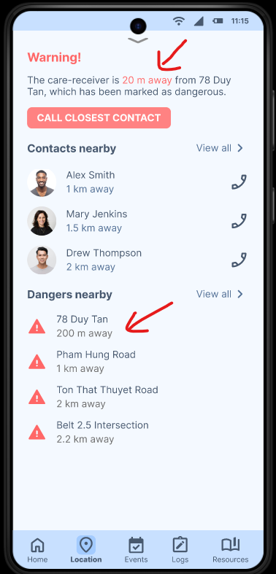
Fig. 1: Inconsistency in the distance of a dangerous location.

Problem 2 - Icon clarity and button labelling
Severity rating: Major (Frequency: Common, Impact: Difficult to overcome, Persistence: Ongoing)
Some participants, particularly less tech-savvy users, struggled to understand the icons used for buttons. While the icons were intended to represent specific functions, they were not universally interpreted as intended. As a result, participants expressed a preference for labelled buttons to make their functions clearer. Incorporating text labels alongside icons can improve accessibility and reduce confusion, especially for users with varying levels of technical competence.
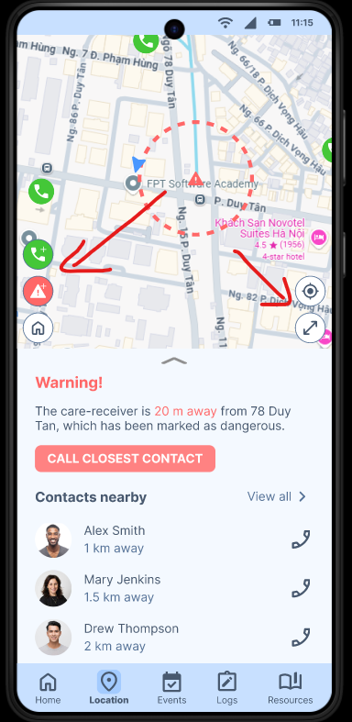
Fig. 2: Buttons that do not have labels.

Problem 3 - Button size and visibility
Severity rating: Major (Frequency: Common, Impact: Difficult to overcome, Persistence: Ongoing)
Another usability issue identified was the small size of some buttons, which made them difficult to locate and interact with on the screen. This was particularly problematic when participants needed to quickly find and tap on a specific function. Ensuring that buttons are appropriately sized and easily distinguishable can enhance interaction, particularly for users who may have limited dexterity or visual acuity.
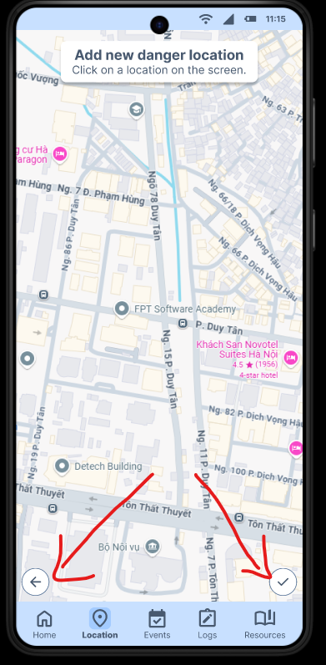
Fig. 3: Small button size in one of the pages, making them harder to find.

Problem 4 - Ambiguity in location wording
Severity rating: Minor (Frequency: Common, Impact: Easy to overcome, Persistence: One time)
On the Location page, the wording used to display the care-receiver’s location was not clear. The app displayed the nearest dangerous location instead of the actual location of the care-receiver. This ambiguity confused participants and led to incorrect assumptions about the care-receiver’s position. Clearly labeling the care-receiver’s current location and differentiating it from nearby danger zones will help prevent such misunderstandings.
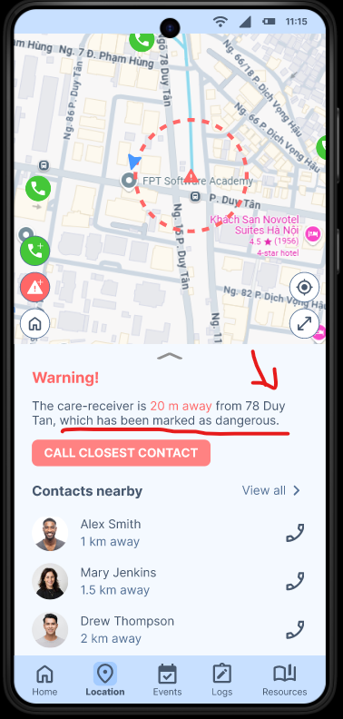
Fig. 4: The text shows 78 Duy Tan, but this is actually the location of the nearest danger, not the care-receiver’s location.

Problem 5 - Lack of error feedback
Severity rating: Major (Frequency: Common, Impact: Difficult to overcome, Persistence: Ongoing)
The prototype also lacked feedback when users made errors. The current design assumed that participants would always input information correctly, which proved problematic when errors occurred. Without feedback, users were unsure if their actions were successful or if they needed to correct something. Implementing error messages or prompts when invalid inputs are detected would guide users towards resolving mistakes efficiently.
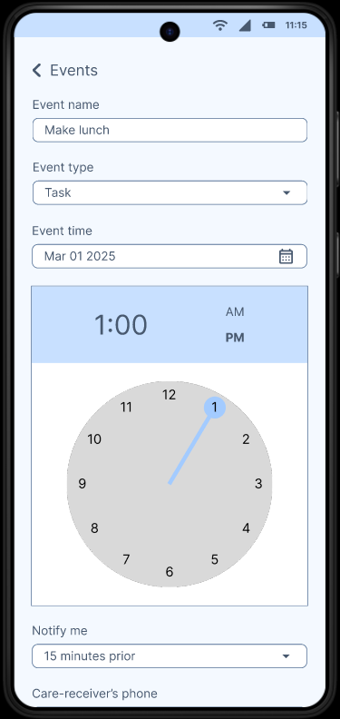
Fig. 5: The form does not show any feedback if the user makes mistakes.

6 Limitations
The usability evaluation faced several limitations that could have impacted the quality and reliability of the results:
- Small sample size: Only four participants took part in the study. While the feedback obtained provided useful insights, the limited number of participants restricts the generalizability of the findings. In future evaluations, increasing the number of participants would enhance the reliability of the results and better represent the user group.
- Participant hesitation: Some participants appeared hesitant to interact with the prototype and were afraid to make mistakes, despite being reassured that any issues encountered were due to the prototype itself, not their actions. This hesitation limited their willingness to explore the interface freely and articulate their thoughts openly. In future evaluations, conducting a brief warm-up task could help participants feel more comfortable.
- Individual interviewing: Due to the nature of the evaluation setup, each team member conducted interviews individually, without the presence of other team members. This lack of cross-checking might have led to inconsistencies in how tasks were presented or how participants were guided through the process.
- Remote interview: The evaluations were conducted remotely to suit participants' convenience. However, this may introduce distractions, which could affect participants’ focus. During some sessions, participants seemed rushed and did not carefully read the forms, possibly leading to less thoughtful responses. In future evaluations, conducting in-person evaluations, where feasible, would allow for better environmental control.
- Familiarity with team members: Since some participants were personally acquainted with the team members, they may have felt inclined to provide praise rather than criticism. This familiarity bias could compromise the objectivity of the results. In future evaluations, we could recruit participants who have no personal connection to the interviewers or employ a neutral facilitator to reduce bias.

References
Brodaty, H., & Donkin, M. (2009). Family caregivers of people with dementia. Dialogues in Clinical Neuroscience, 11(2), 217–228. https://doi.org/10.31887/DCNS.2009.11.2/hbrodaty
Lorenz, K., Freddolino, P. P., Comas-Herrera, A., Knapp, M., & Damant, J. (2019). Technology-based tools and services for people with dementia and carers: Mapping technology onto the dementia care pathway. Dementia, 18(2), 725–741. https://doi.org/10.1177/1471301217691617
Wandering | Alzheimer’s Association. (n.d.). Alzheimer’s Association. Retrieved February 23, 2025, from https://www.alz.org/help-support/caregiving/stages-behaviors/wandering
What Is Dementia? Symptoms, Types, and Diagnosis | National Institute on Aging. (n.d.). Retrieved January 9, 2025, from https://www.nia.nih.gov/health/alzheimers-and-dementia/what-dementia-symptoms-types-and-diagnosis

APPENDICES
The following documents will be submitted along with the Usability Evaluation Report:
- Informed Consent Form
- Demographic Questionnaire
- Task Questionnaire
- Satisfaction Questionnaire
- Spreadsheets of data collected from evaluation:
  - Demographic Data
  - Task Questionnaire Data (used for measuring Effectiveness and Efficiency)
  - Satisfaction Data

